Quick Start Guide for using the Las Vegas Valley School Map
Prepared by Nevada Action for School Options and the Clark County GIS Department

- Open your browser, go to https://nevadaaction.org/ and click here.
- You will arrive at a map locating over 400 schools and classified into four types of schools:
- CCSD Traditional Schools
- Schools, Private
- Charter Schools
- Magnet School
- Click on the top icon in the tool bar
Tool Bar
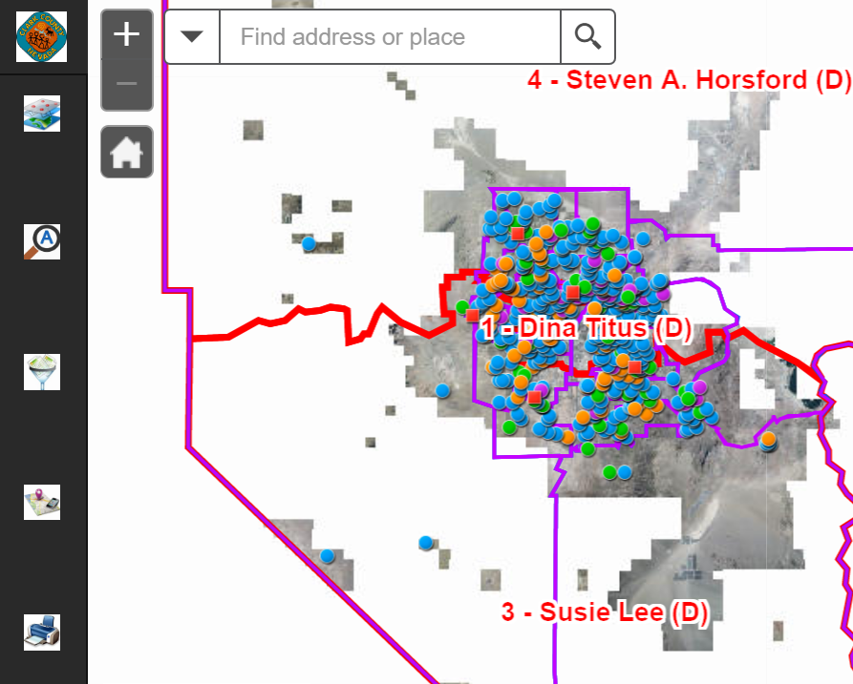

- You will arrive at the LEGEND with the tool bar on top:
School Type | Input Key
CCSD Traditional School | CCSD
School Private | Private
Charter School | Charter
Magnet School | Magnet
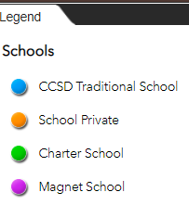
Type in these Input Keys to select the group of schools pinpointed on map.

- There are four function tools for exploring the school data:

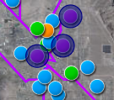
QUERY tool presents a way to display the schools by type when the Input Key (see step 4) is entered at the “Query criteria” box. Then click the “Apply” at bottom of Query page. Schools will display as colored dots in the map.
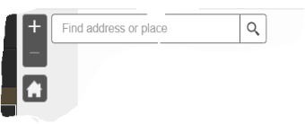
If a specific school name or street address is needed, type either into this box shown left. This input box is located at the top left corner of the map.

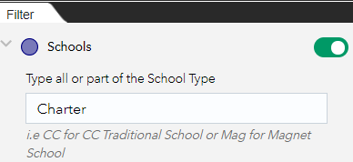
The FILTER icon brings a way to display all the schools of a certain type. The green switch needs to be “on” as displayed here.
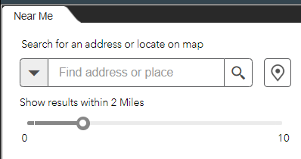
The NEAR ME icon presents a way to enter an address such as a home and set a radius in miles. The results is a display all schools within the circle.

The Print function will only print a map with ALL schools included. An alternative is to print the screen or use a snipping tool.

For technical support or corrections relating to address or name, please call 702.202.3573 or email info@nevadaaction.org with MAP in subject line.

